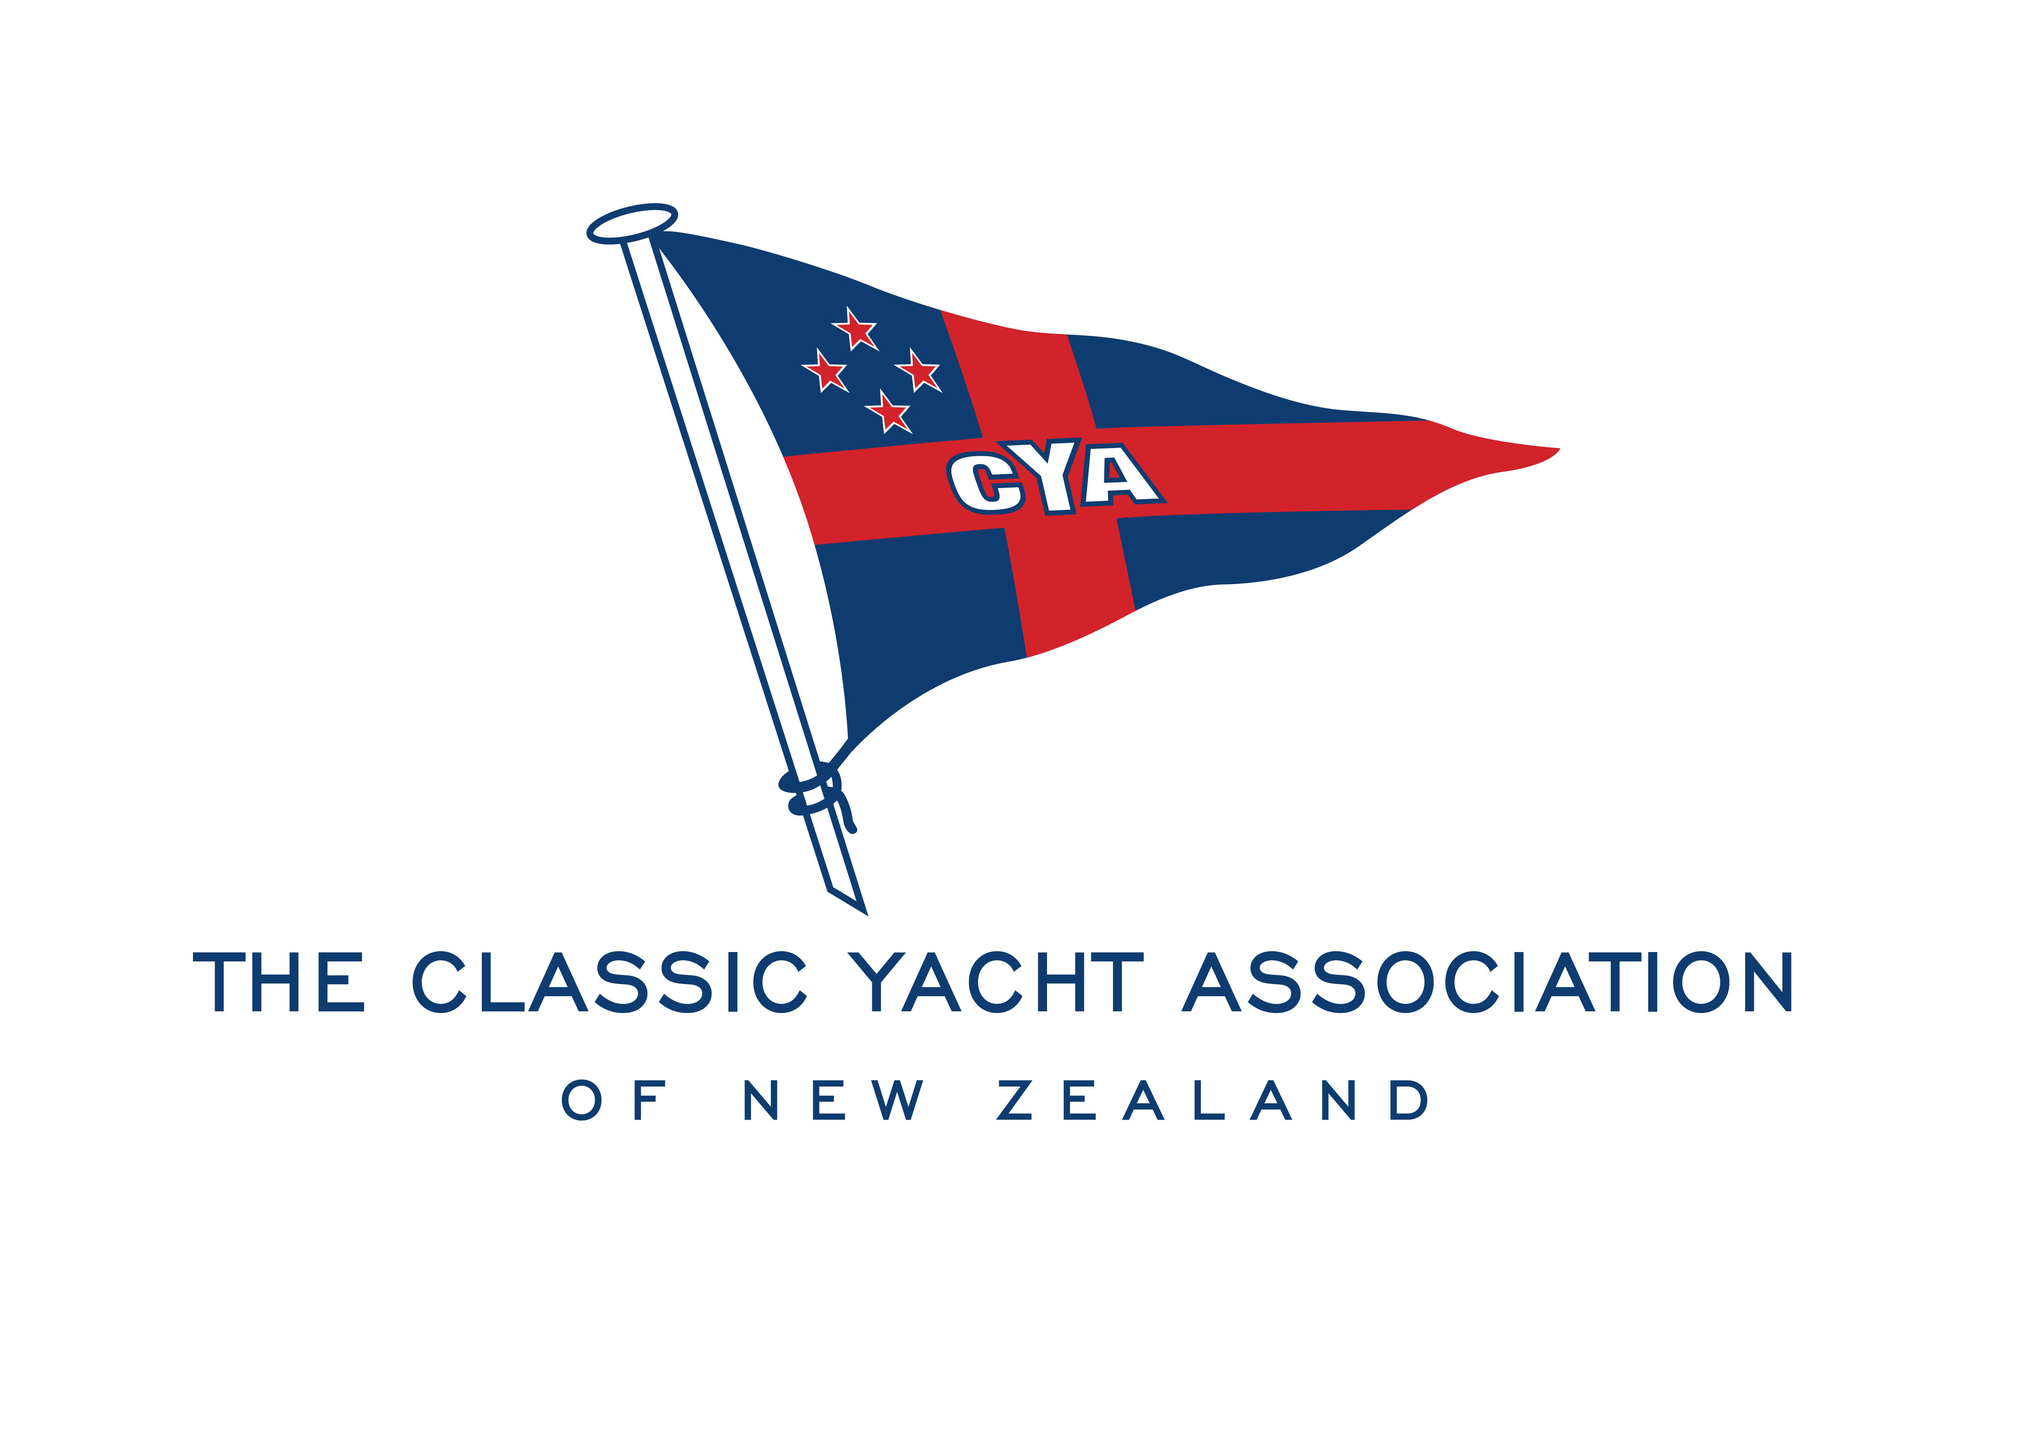

TWENTY-SIXTH ANNUAL GENERAL MEETING
of the Classic Yacht Association of New Zealand Incorporated
to be held at Royal New Zealand Yacht Squadron, Westhaven
TUESDAY 3rd AUGUST 2021 at 7.00pm

AGENDA:

Apologies

Notice of Meeting Confirmation

Adoption of Minutes of the Twenty-Fifth Annual General Meeting held 4 August 2020

Presentation of Accounts – Year ended 30 June 2021

Chairman’s Report

Election of Executive Committee Members
Chair
Vice-Chair
Yacht Captain
Launch Captain
General Committee (5 members)

General Business
Report on the status of the expanded classic vessel marina/dock

Copies of the Minutes of the Twenty-fifth Annual General Meeting and the Accounts for the year ending
30 June 2021 will be available at the Royal New Zealand Yacht Squadron on the night of the AGM.

