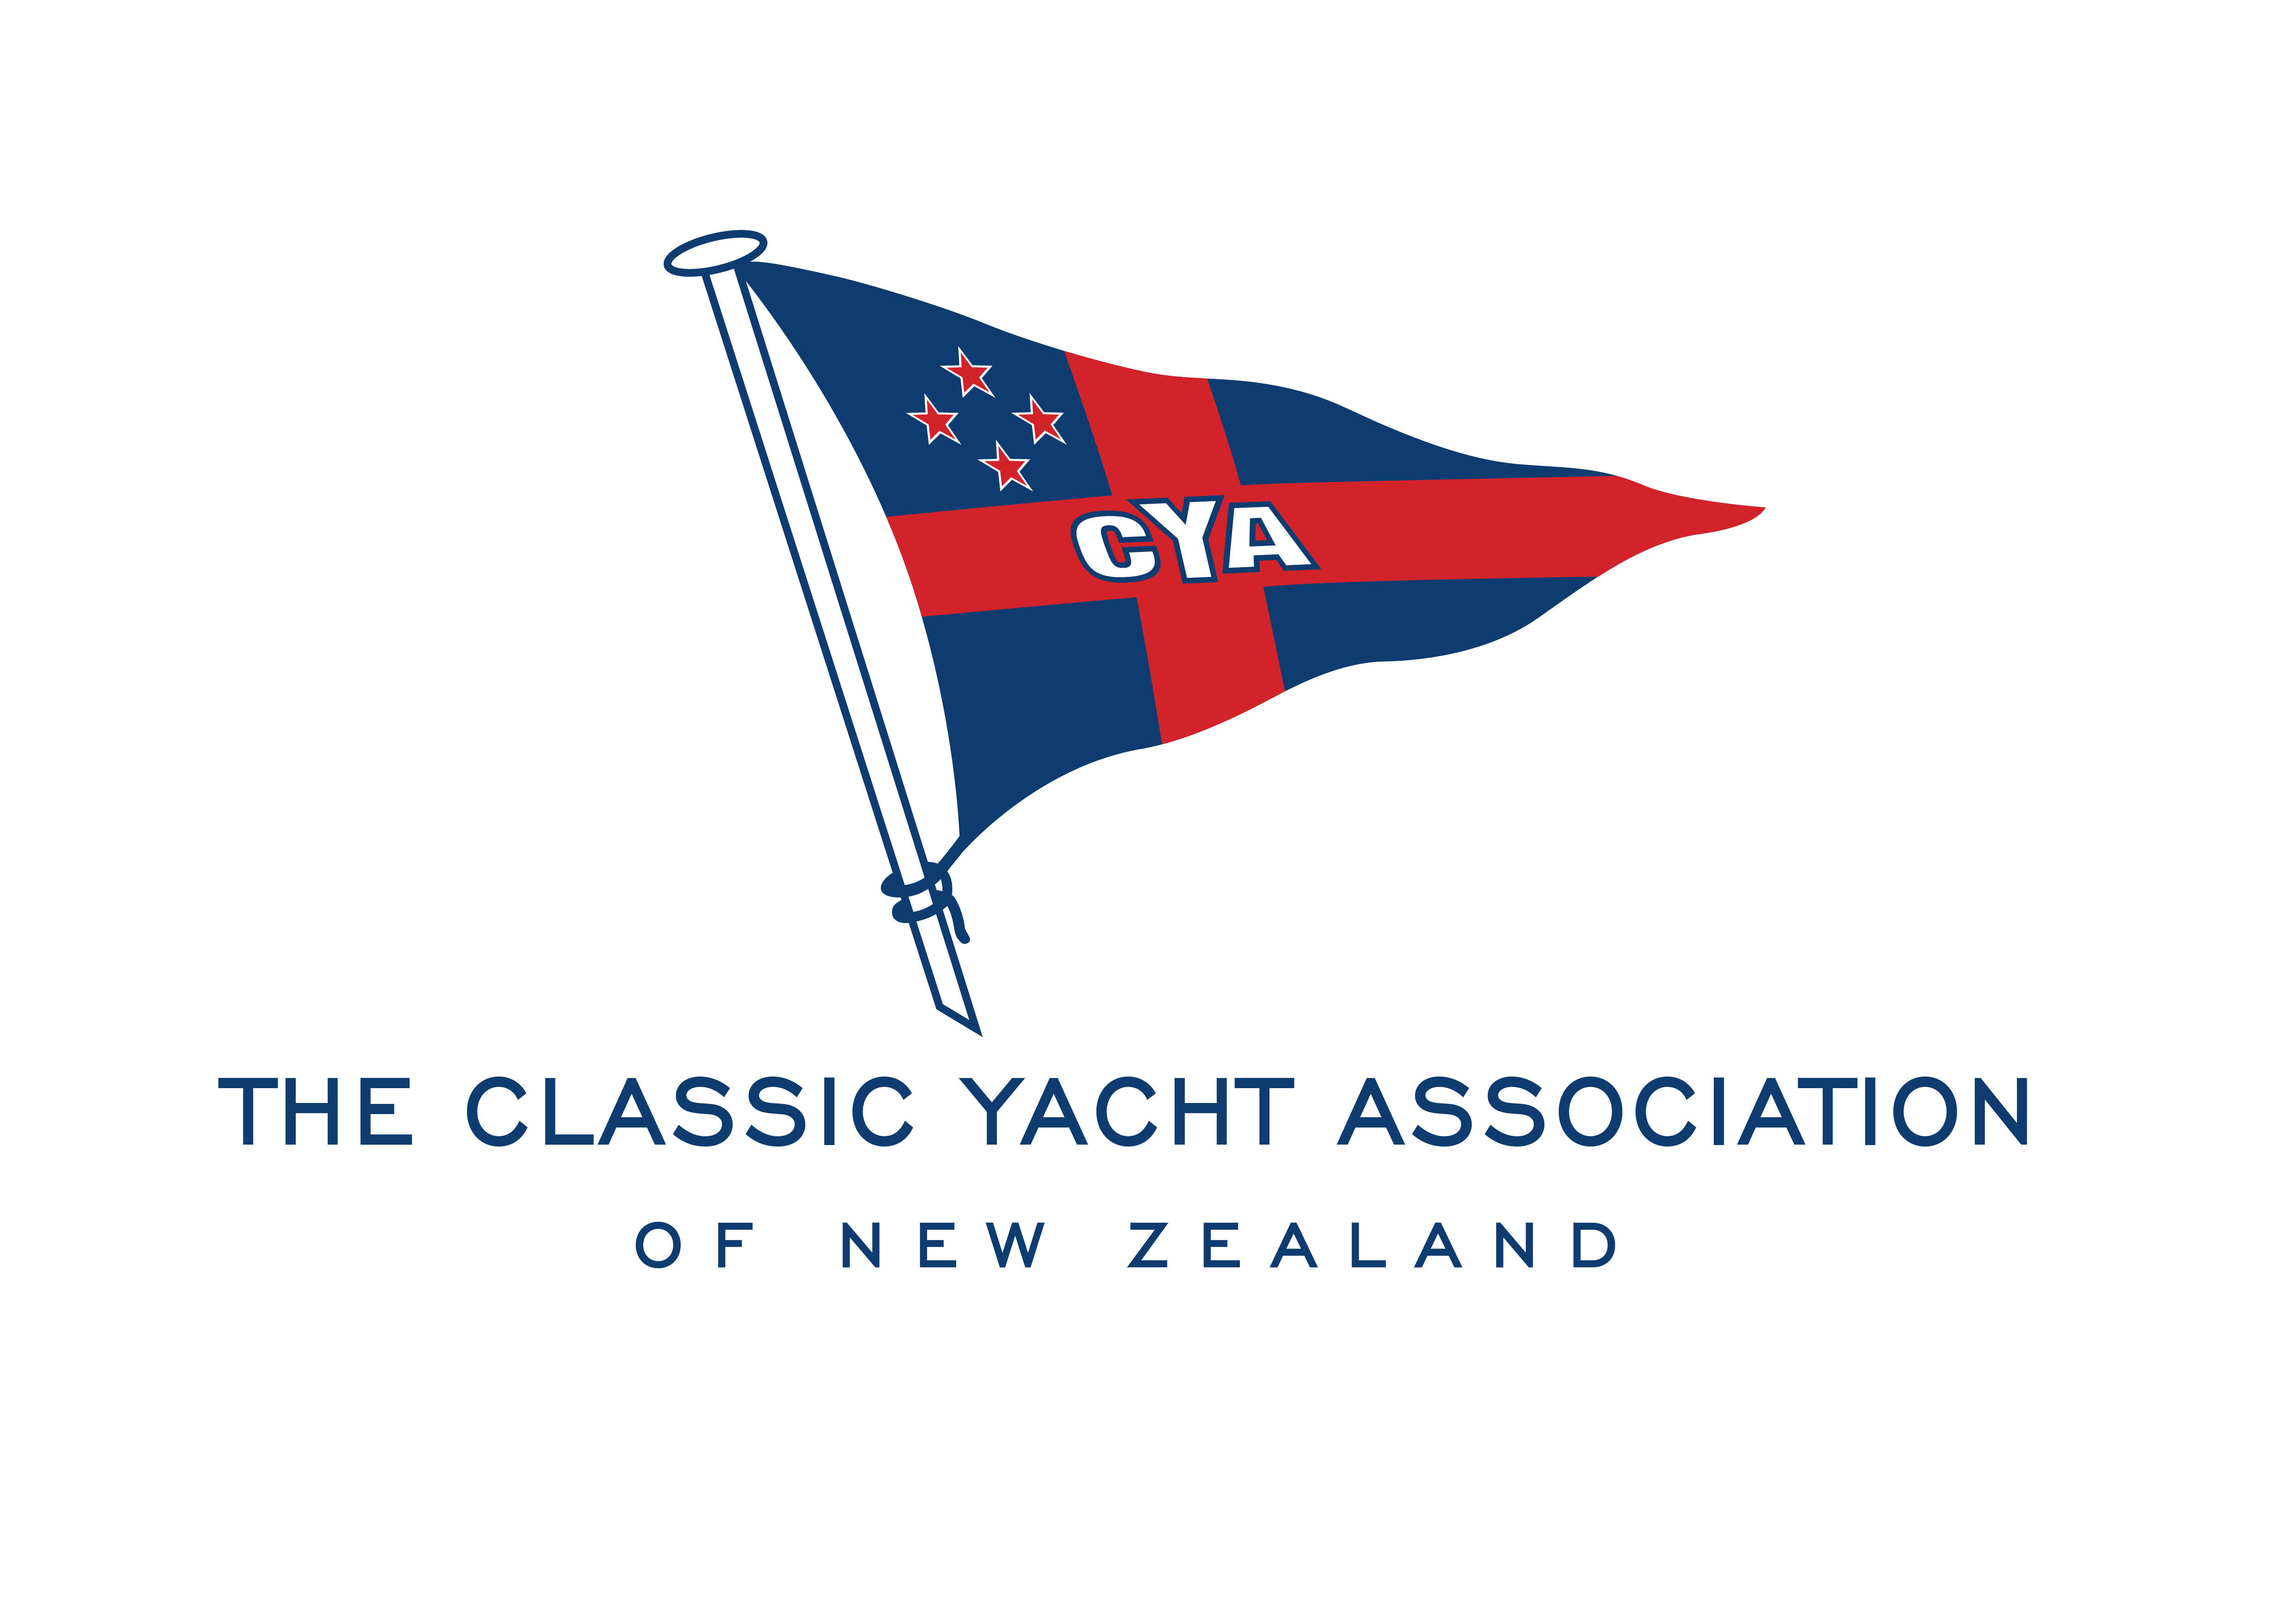

MINUTES of the TWENTY-FIFTH ANNUAL GENERAL MEETING
of the Classic Yacht Association of New Zealand Incorporated
held at Royal New Zealand Yacht Squadron, Westhaven
TUESDAY 4th AUGUST 2020 at 7.00pm

Chair James Mortimer presided over and welcomed the 56 members and guests present at the Twenty-Fifth Annual General Meeting of the Classic Yacht Association.

The Chair called on Shirley-Ann McCrystal, to present the Gloriana Cup to the Classic Yacht Association of NZ on behalf of Peter Murray, grandson of one of the original owners. The Gloriana Cup is to be presented to the Best Performed Overall B Division gaff-rigged yacht over the season.
The Chair then called up Hamish Ross to present a Life Membership certificate to Chad Thompson.
Hamish outlined the years of time and effort Chad had put into the Association since it’s inception in 1995, and presented the framed certificate to Chad.
Chad thanked the Association and all present for his award.

Apologies:
Richard Cave, Sir David Mauger, Martin Robertson, Chris Collins, John Erkkila, Tom Kane, Graeme Finch, Bruce Pullan, Emily Dimock, Iain Valentine, Michelle Kahn, Tony Stevenson, Bruce Dunlop,
Stephen Blackhall, Larry Paul, Bert Woolcott, Robyn Pearce, Chris Leech.
Apologies accepted: James Mortimer/Margaret Woolcott - carried

Notice of Meeting Confirmation:
The Chair confirmed that notice of the 20120 Annual General Meeting had been issued in accordance with the Rules of the Association.

Adoption of Minutes of the Twenty-fourth Annual General Meeting held 12 August 2019:
The date of the 2019 Minutes was corrected to read 12 August 2019 and the Minutes having been circulated, were confirmed as a true and correct record.
Moved ‘that the Minutes be approved and accepted: James Mortimer/John Duder - carried

Annual Accounts:
The Annual Accounts for the year ended 30th June 20 were prepared by Robert Taylor of William Buck Ltd, Chartered Accountants, having been reviewed and approved by the Executive Committee, were circulated at the meeting.
Rob Taylor presented the accounts noting the strong financial position of the Association.
Questions from the floor were called for, there were no questions.
Moved ‘that the financial accounts be received and adopted”: James Mortimer/Hamish Ross - carried

Chair’s Report:
The Chair read his Annual Report which was circulated, to the members.

Election of Executive Committee Members:
The following members were proposed and seconded as listed:
Chair: Rachel Orr James Mortimer/Joyce Talbot
Vice Chair: Jonathan Curtis Rachel Orr/James Mortimer
Patrick O’Meara Hayden Afford/John Street
Yacht Captain: Richard Cave James Mortimer/Rachel Orr
Launch Captain: Jason Prew Maxim Goutard/Joyce Talbot

General Committee: Alan Turner Joyce Talbot/James Mortimer
Andy Ball Richard Allen/James Mortimer
Bruce Dunlop Joyce Talbot/Rachel Orr
Jason Davies Joyce Talbot/James Mortimer
Patrick O’Meara Haydon Afford/John Street
Tom Bertenshaw Joyce Talbot/James Mortimer

The nominees were invited to speak briefly to the members.
The number of General Committee members was raised and confirmed by Hamish Ross that there was a total of five only allowed to be elected, and any change would require a Special General Meeting. It was noted that interested members could become co-opted onto sub-committees.
All nominees were asked to confirm their intention to stand on the executive committee for the full twelve months and Bob Still asked the nominees if any of them had been refused admittance to a Yacht Club. There was no response.
Members were then invited to complete a ballot form and vote for the Vice Chair and five committee members requiring votes..
Hamish Ross and Chad Thompson retired to count the votes and returned confirming Jonathan Curtis as the Vice-Chair and committee members as follows:
Andy Ball
Alan Turner
Bruce Dunlop
Jason Davies
Tom Bertenshaw

Subscriptions:
The following items have been received for approval:
- ‘that a new class of Membership be introduced for CREW with a subscription of $40.00.
This subscription does not qualify the member to receive a Vessel Register’ or voting rights’.
A discussion followed and it was agreed ‘that the new Crew membership with voting rights be added to the Rules with a review to take place after one year’ Hamish Ross/Chad Thompson – carried.

- ‘that Skippers of vessels participating in CYA Series races /events must be a current member of the
Association’. James Mortimer/Tom Bertenshaw - carried
- ‘that all other Membership classes and subscription fees remain the same as per 2019-20 Season’.
James Mortimer/Margaret Woolcott - carried

General Business:
(i) America’s Cup
In response to an enquiry regarding activities of the Association during the America’s Cup period it
was noted that due to Covid-19 and the difficulties in obtaining visas, several international classic
vessels including the J class had cancelled their proposed visit. Hamish advised visas would only be
considered for those vessels guaranteeing $50,000 worth of upgrades and repairs.

It was confirmed the Classic Yacht Regatta would be held 27 Feb/1 March and the Association would support the 100th Lipton Cup to be held on 21 March.
It was also hoped the A Gaff-rigged yachts would sail on the course prior to the commencement of one of the America’s Cup races.

(ii) Outgoing Committee
Margaret Woolcott thank the outgoing committee for their time and efforts over the past year.
(iii) Membership Numbers
In response to a query from Alan Houghton regarding the numbers, it was explained that the cut-off
date for current members was now in line with the end of the financial year of 30th June, instead of
August prior to invoicing as had previously been in place.
(iv) Heritage Landing
Berthage at the Landing was queried and it was explained that the website offered a Registration of Interest form for any vessel owner who wished to apply. A proposal regarding future berthage, the current rate of $75.00 per month and the expectation that the CYA would be expected to cover upgrades to the wharf was currently under review with Panuku.
The lack of parking was noted and could be considered for review once the outcome of the proposal was known.

Chad Thompson, Bruce Dunlop and Andy Ball were sincerely thanked for their time and efforts in putting the proposal together and their ongoing communications with Panuku.

(v) Vos Shed
The future of the CYA’s use of the Vos Shed was unknown at this point but James Mortimer noted the
building was scheduled to be completed prior to the America’s Cup

(vi) 2020-2021 Calendar of Events
It was advised the calendar would be produced in the near future

There being no further business, the Chair thanked everyone for their attendance, wished every-one well for the coming year and closed the meeting.

The meeting closed at 8.42pm

