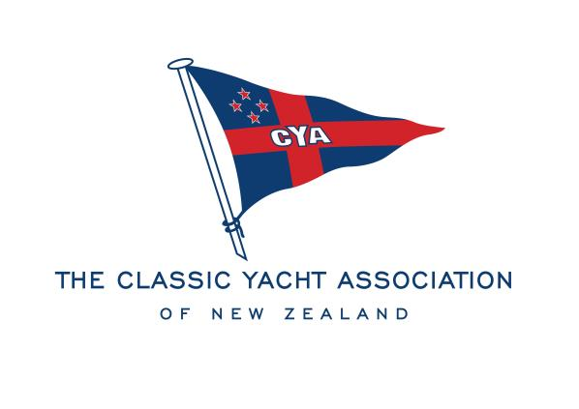

NOMINATION FORM

We wish to nominate ..................................................................................... for the office of:
CHAIR
VICE CHAIR
YACHT CAPTAIN
LAUNCH CAPTAIN
GENERAL COMMITTEE
(Strike out offices not nominated for)
of the Classic Yacht Association of New Zealand Incorporated for the 2022-23 Season
Signature of Proposer:..........................................................................
Signature of Seconder:.........................................................................

I agree to the Nomination:...................................................................
Signature of Nominee
All the above must be financial members of the Association and nominations must be in the hands of the Secretary no later than 1700hrs on Tuesday 26 July 2022.
E: admin@classicyacht.org.nz

