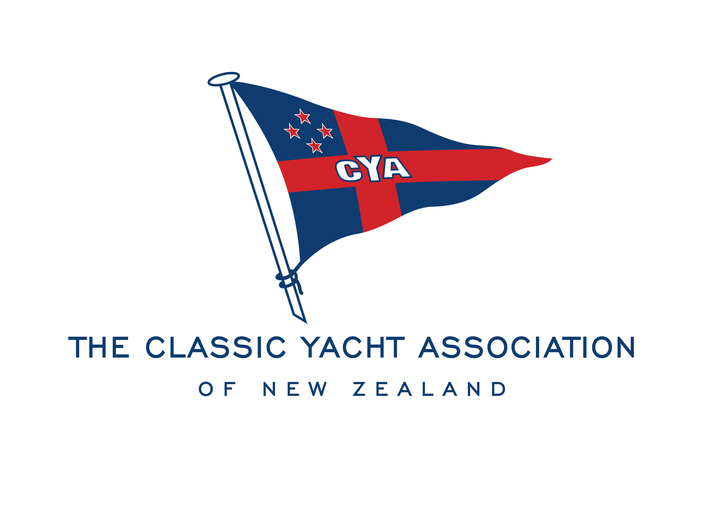

PROXY FORM

I ………………………………………………………......................am unable to attend the CYANZ AGM to be held on 2nd August 2022 at 7pm at the Royal NZ Yacht Squadron and appoint the Chair to tender my vote to the following matters:

I would like to vote for the following members for the allocated roles below.

CHAIRMAN………………………………………………………………………………………………….

VICE CHAIRMAN……………………………………………………………………………………………

YACHT CAPTAIN……………………………………………………………………………………………

LAUNCH CAPTAIN…………………………………………………………………………………………

GENERAL COMMITTEE MEMBER……………………………………………………………………....

My proxy form will be in the hands of the Secretary no later than 5.00pm on Tuesday 26 July 2022

Name___________________________________

Signature________________________________

