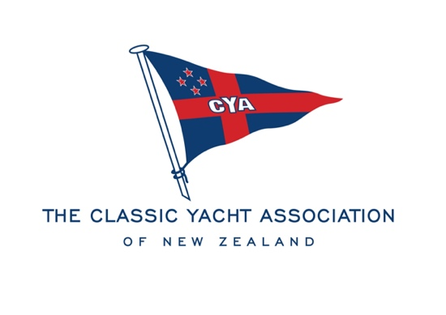

Notice of Annual General Meeting

Dear Members,
Notice is hereby given that the Annual General Meeting of Classic Yacht Association of New Zealand Inc will be held on Tuesday 3 August 2021 at the Royal NZ Yacht Squadron commencing at 7.00pm.

The Agenda and Nomination Forms for the following committee positions will be available online
the week commencing Monday 12 July 2021 and nominations will close at 1700hrs on Tuesday 27 July 2021. The Agenda and Nomination Form can be posted on request.

Chair
Vice Chair
Yacht Captain
Launch Captain
5 x General Committee

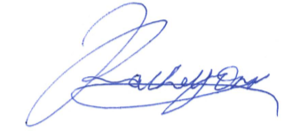

Rachel Orr
Chair
Classic Yacht Association of NZ Inc

